**DAILY ONLINE ACTIVITIES SUMMARY**

|  |  |  |  |  |  |  |  |  |
| --- | --- | --- | --- | --- | --- | --- | --- | --- |
| **Date:** | 19/05/2020 | | | | | **Name:** | RIYA C.P | |
| **Sem & Sec** | IV B | | | | | **USN:** | 4AL18CS070 | |
| **Online Test Summary** | | | | | | | | |
| **Subject** | | Design and Analysis of Algorithms | | | | | | |
| **Max. Marks** | | 30 | | **Score** | | | 15 | |
| **Certification Course Summary** | | | | | | | | |
| **Course** | Python for Machine Learning | | | | | | | |
| **Certificate Provider** | | | Greatlearning academy | | **Duration** | | | 5.0 hours |
| **Coding Challenges** | | | | | | | | |
| **Problem Statement:** A user will input two strings, and we find if one of the strings is a sub sequence of the other. Program prints “yes” if either the first string is a sub sequence of the second string or the second string is a sub sequence of the first string. Assume that, the length of the first string is smaller than or equal to the length of the second string. | | | | | | | | |
| **Status: Executed** | | | | | | | | |
| **Uploaded the report in Github** | | | | | YES | | | |
| **If yes Repository name** | | | | | Lockdown-coding | | | |
| **Uploaded the report in slack** | | | | | YES | | | |

**Online Test Summary:** 18CS42 test was scheduled from 9:15 am t0 9:55 am .The portion for the IA was 1st module there were 30 questions and the time assigned was 40 minutes the questions were mcq type. There were 20 questions of 1 marks and 5 questions of 2 marks.

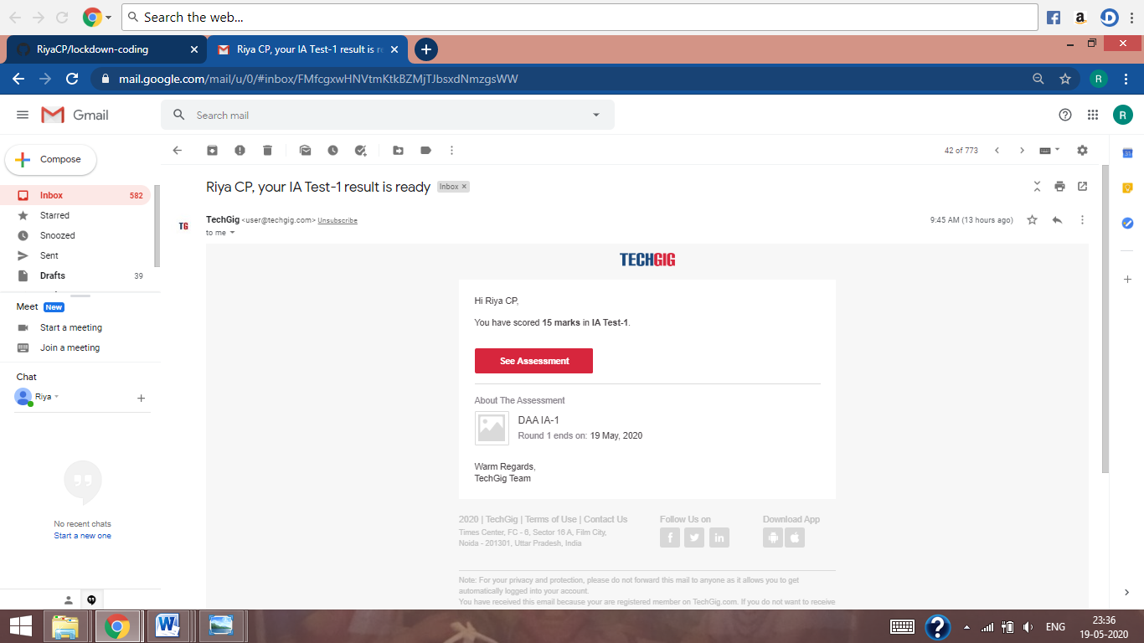

The above snap shot is the completion of the test and the marks allotted.

**Online Certification Course Summary**: Today I have continued with the course and learnt about Anaconda installation and about jupyter notebooks. Anaconda is available free of coast and it is having two versions at present one is 2.7 and the other is 3.7.I have also downloaded Anaconda 3.7 version in my PC. It is one of the platform to Execute python programs and we will also find different IDE’s in Anaconda. In Anaconda command prompt if we write conda list were conda is the basic keyword then we will get list of items which are installed for python. It is shown in the below snap shots.

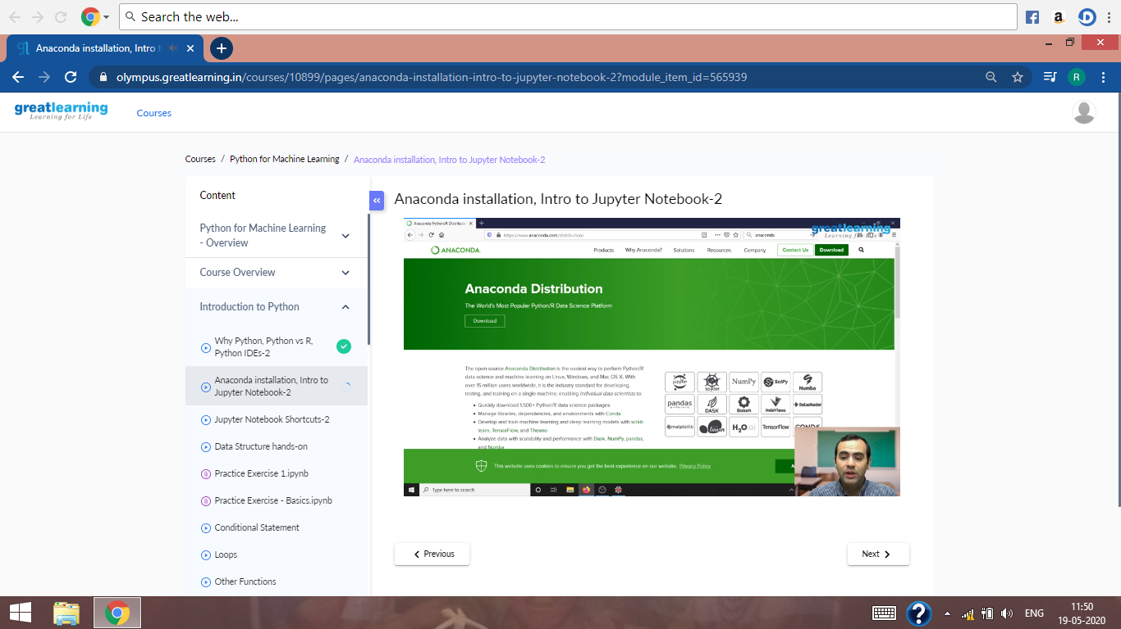

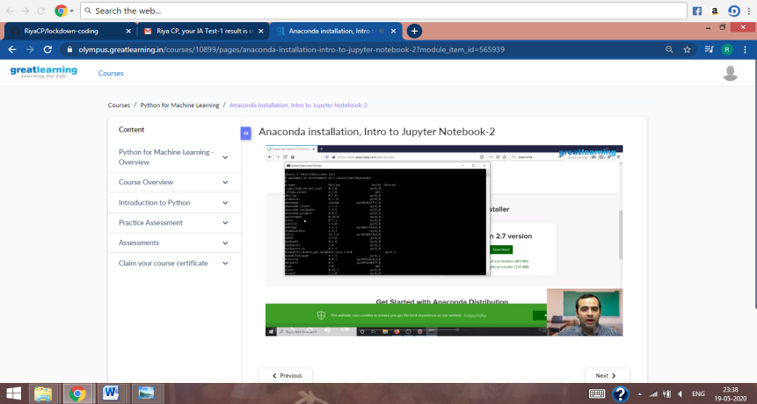

Then I have learnt about the jupyter notebooks , how to create a new note book and how to execute the code in the cell provided in the notebook and about some of the keyboard shortcuts which helps to execute the code and to achieve the output.

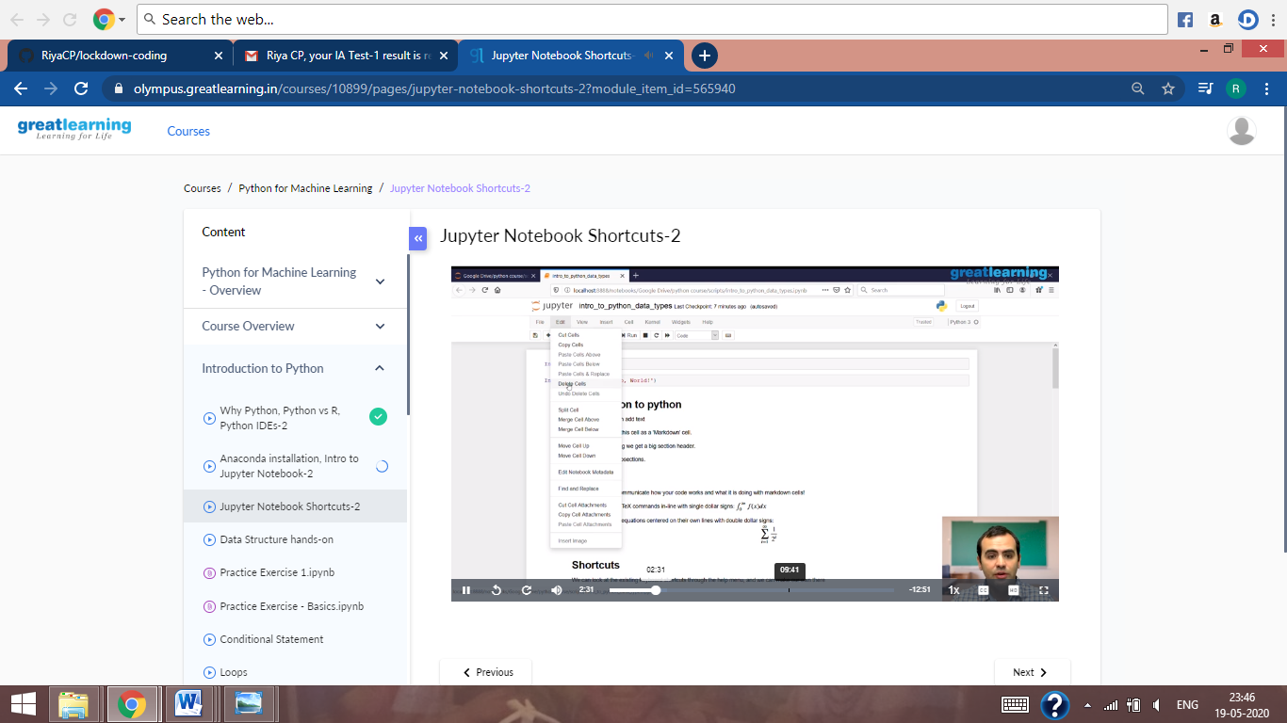

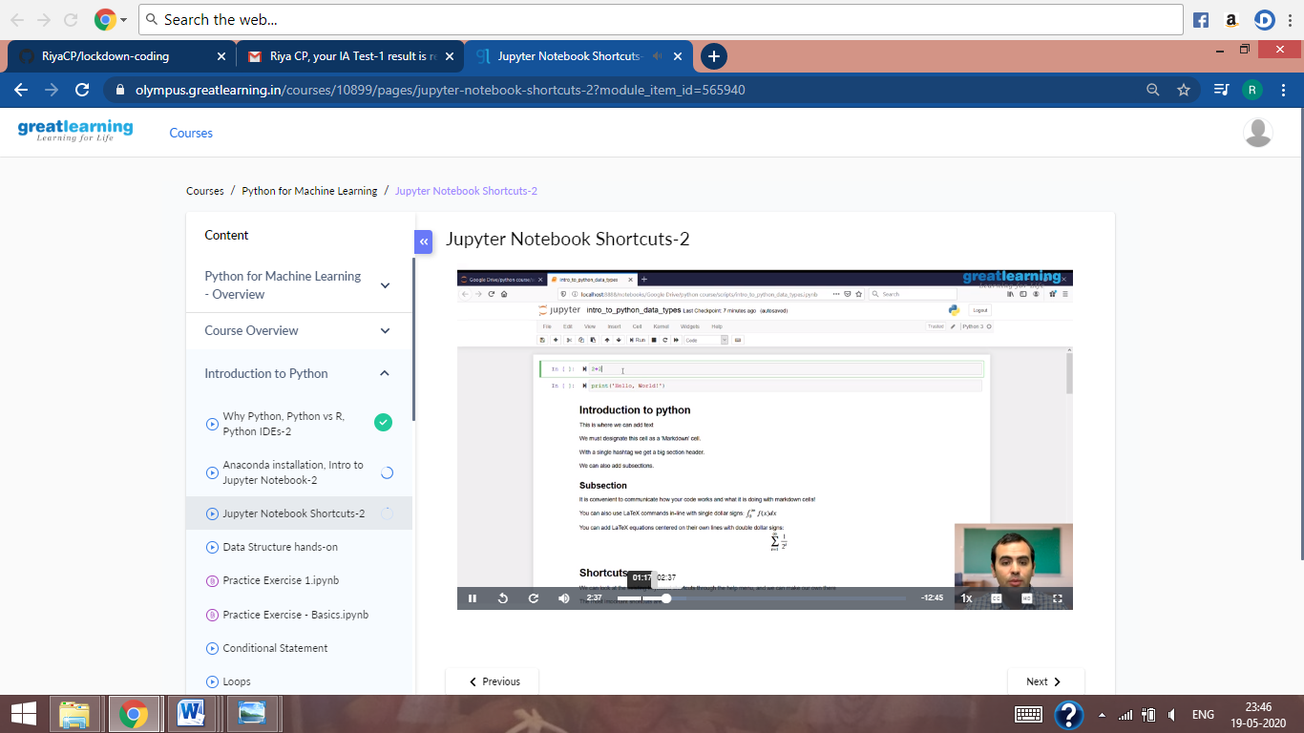

These are the snap shots of jupyter notebook and some of the shortcuts.

**Online Coding Summary:** Online coding Summary: Today I had received one program from prof.Venkatesh CSE Dept. The programs is mentioned above in the coding challenges(pg.01). I have also uploaded it to my Github repository**.**

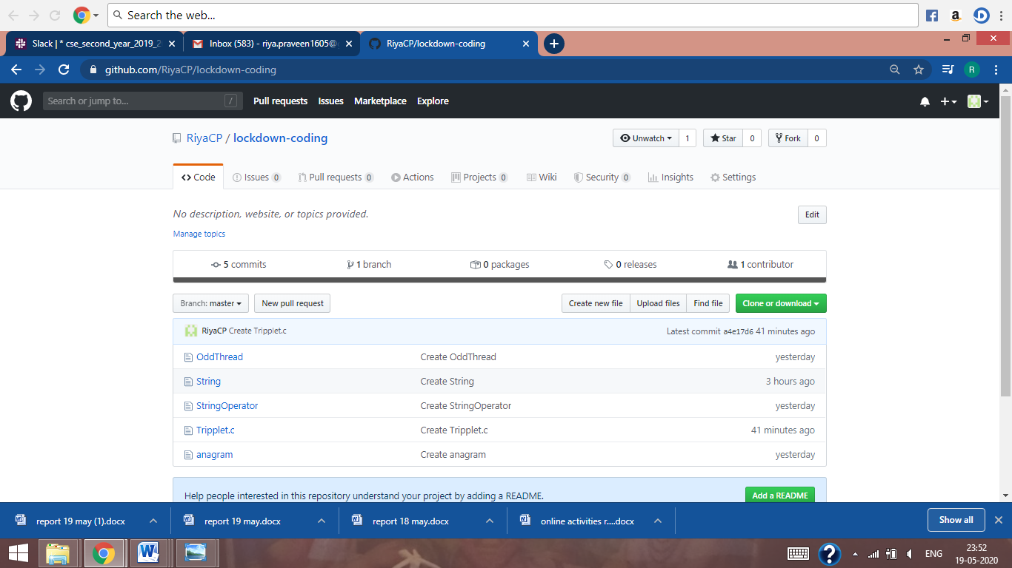

It is the snap shot of my repository were I have uploaded the code. File name is string.c